**IGCSE Design Technology**

**Module 11**

**General Concepts & Principles**

Your Name \_\_\_\_\_\_\_\_\_\_\_\_\_\_\_\_\_\_\_\_\_\_\_\_\_\_\_\_\_\_\_\_\_\_\_\_\_\_\_\_\_\_\_\_\_\_

**IGCSE Design Technology**

**General Principles & Concepts**

**Mechanical Advantage** is a measure of the force amplification achieved by using a tool, mechanical device or machine system. Ideally, the device preserves the input power and simply trades off forces against movement to obtain a desired amplification in the output force. The model for this is the *law of the* [*lever*](http://en.wikipedia.org/wiki/Lever)*.*

[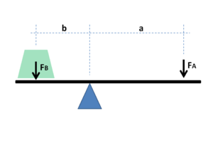](http://en.wikipedia.org/wiki/File:Lever_mechanical_advantage.png)The [lever](http://en.wikipedia.org/wiki/Lever) is a movable bar that pivots on a fulcrum attached to or positioned on or across a fixed point. The lever operates by applying forces at different distances from the fulcrum, or pivot.

If *a* and *b* are distances from the fulcrum to points *A* and *B* and if force *FA* applied to *A* is the input force and *FB* exerted at *B* is the output, the ratio of the velocities of points *A* and *B* is given by *a/b*, so the ratio of the output force to the input force, or mechanical advantage, is given by

MA = \frac{F_B}{F_A} = \frac{a}{b}.



**DRIVER GEAR has 10 teeth.**

**DRIVEN GEAR has 20 teeth.**

**Velocity Ratio** is about the relationship between the turning speeds of one gear wheel compared to another. In this example the velocity ratio between the driver and the driven is 2:1 the driver turns two times and the driven gear turns once.

The formula for Velocity Ratio (VR) is

VR = Driver or 10

Driven 20

The same principles apply to pulley systems but the velocity ration is calculated using the diameter of each pulley wheel.

The driver pulley has a diameter of 200mm, the driven pulley wheel has a dimeter of 400mm.

The velocity ratio is VR = Diameter of Driver

Diameter of Driven

In this example the velocity ratio between the driver and the driven is 2:1 the driver pulley turns two times and the driven pulley turns once.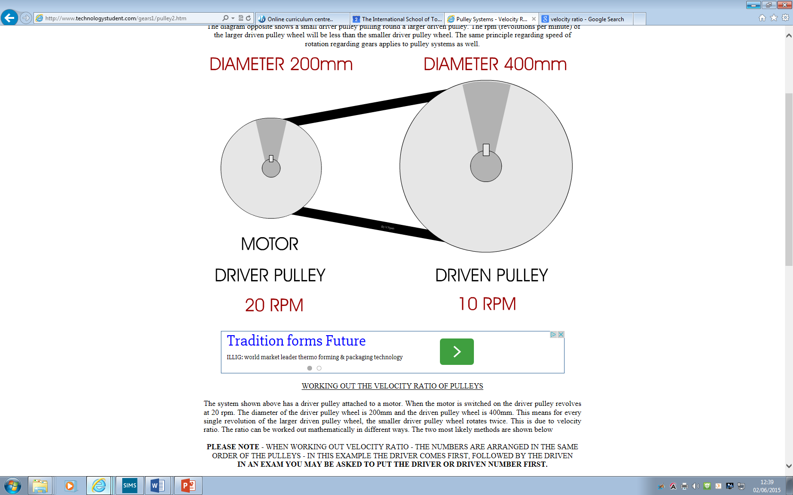

**Mechanical Efficiency**

**Mechanical efficiency** measures the effectiveness of a [machine](http://en.wikipedia.org/wiki/Machine_(mechanical)) in transforming the energy and power that is input to the device into an output force and movement. Efficiency is measured as a ratio of the measured performance to the performance of an [ideal machine](http://en.wikipedia.org/wiki/Ideal_machine):

\text{Efficiency} = \frac{\text{Measured performance}}{\text{Ideal performance}}

The ideal performance of a mechanism occurs when the output power equals the input power, that is, when there are no losses. Real devices loose power through friction which generates heat. Therefore, some of the input energy is lost in the form of heat caused by friction.

**Levers**

You need to use the correct terms and be able to draw and identify the three classes of levers









**Transmission of Motion**

**Gears**

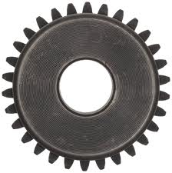

**Spur gear.**

****

**Simple Gear Train Compound Gear Train**

****

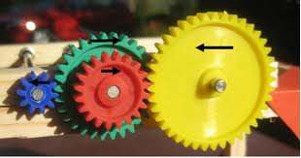

**Mitre Gear Wheels Worm Gear & Wheel**

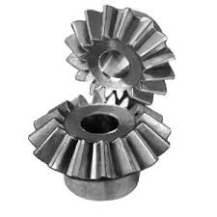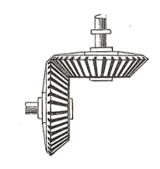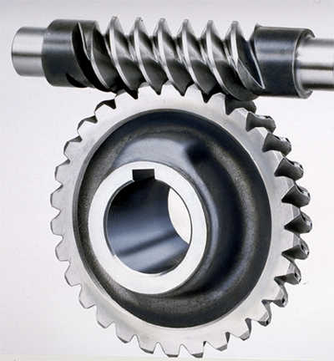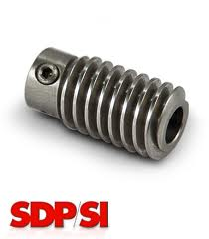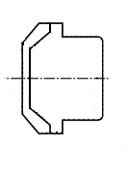

**Symbol**

****

**Rack & Pinion**

**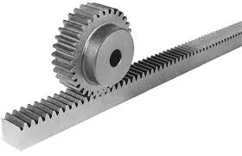**



**Symbol for a**

**Rack & Pinion.**

**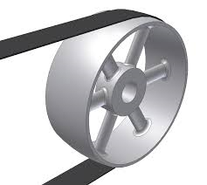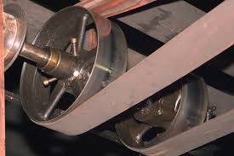Belts and pulleys**

**Flat Pulley Belt & Wheel**

**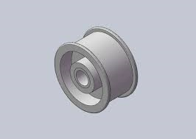Flanged Pulley Wheel**

**V shaped Pulley system**

**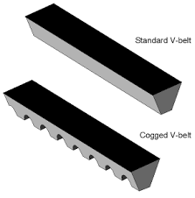**

**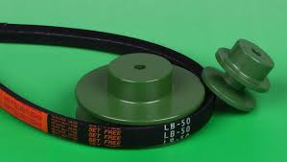**

[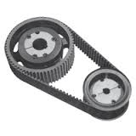](http://www.google.co.uk/imgres?imgurl=http://www.acastronovo.com/ClassHtms/images/BeltPulley.gif&imgrefurl=http://pixshark.com/pulley-and-belt-examples.htm&h=200&w=200&tbnid=wInZgxJ_JyEtVM:&zoom=1&docid=vcnPE0vR3q_mpM&ei=NZNtVaHCHYvnUrjtg6AM&tbm=isch&ved=0CA8QMygLMAs4yAE)

**Toothed Pulley Belt systems**

**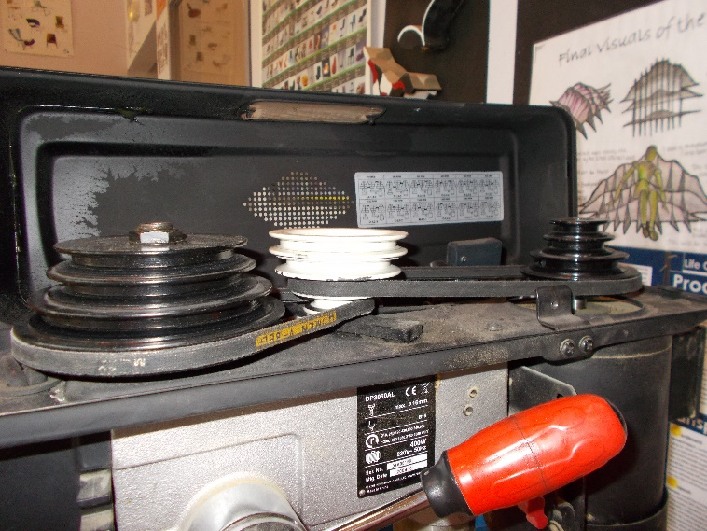**

**Cone Pulley wheels**

**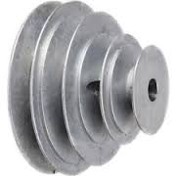**

**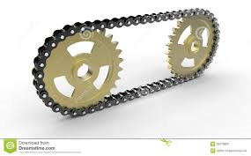Chains and Sprockets**

**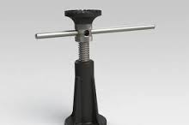Screw Jack**

**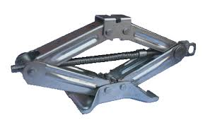Scissor Jack**

**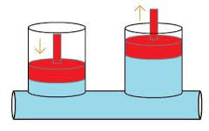Basic Hydraulic Systems**

**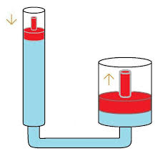**

**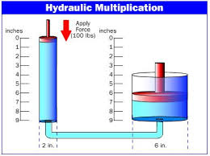**

**Types of Energy**

**Kinetic Energy The energy from an object because of its movement**

**Potential Energy Energy from an object because of its position**

**Electrical Energy Energy in the form of an electrical charge**

**Chemical Energy Energy produced by a chemical reaction**

**Nuclear / Atomic Energy Energy produced by a nuclear reaction**

**Bearings and Lubricants**

Bearings are devices that are fixed onto the moving parts within a mechanism to reduce the effect of friction. Lubricants are liquids or grease used to reduce friction and heat. Friction causes loss of mechanical efficiency and extra ‘wear’ at any point where a moving part rubs against a fixed part.

**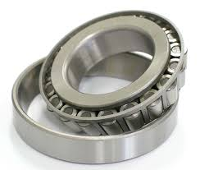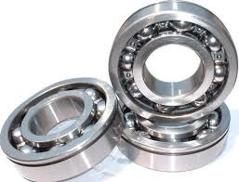**

**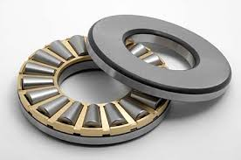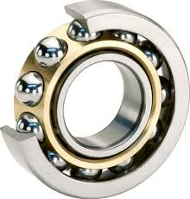**

**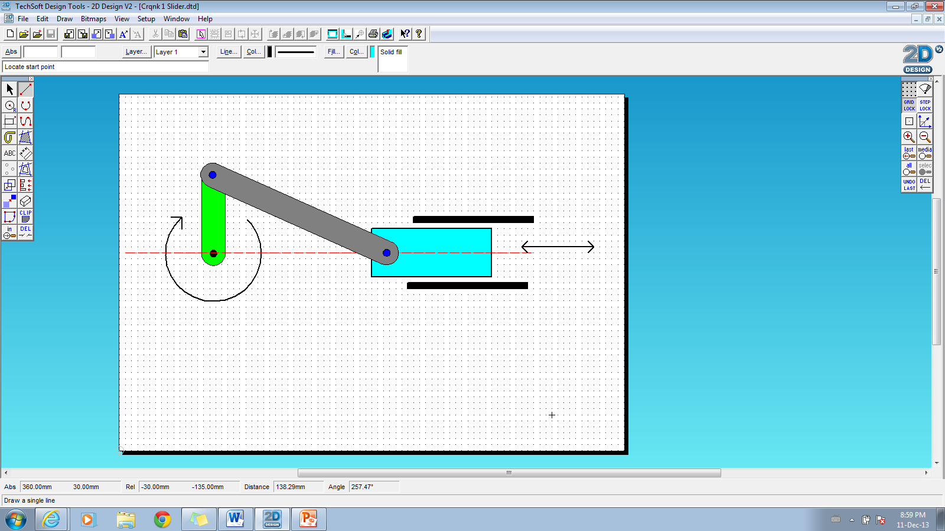**

**Ratchet & pawl**



**Electronics**

* **Component Recognition - Know the symbols for the basic components.**
* **Know about polarity and current flow.**
* **Know the difference between Voltage, Current, Resistance and Capacity.**
* **Know the units for Voltage, Current, Resistance and Capacity.**
* **Know that P = Power, I = Amps, V = Volts and R = resistance**

**Simple electronic calculation using variations of Ohms law**

**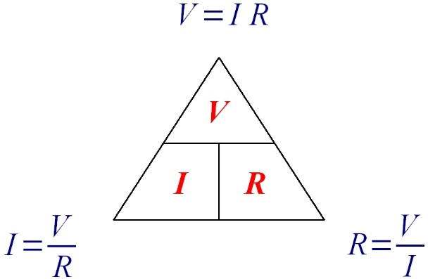**

**Describe and define**

**INPUT PROCESS OUTPUT**

* **Describe the various types of switches that you can use as sensors (INPUT DEVICES)**
* **Describe the various types of transducer sensors that can be used as (INPUT DEVICES)**

**(Thermistors, LDR’s, Strain Gauge etc.)**

* **Describe the various types of components that can be used as (OUTPUT DEVICES)**

**(Motors, LED’s, Speakers, Buzzers, Bulbs, Electro-magnetic components)**

**Describe and define the difference between DIGITAL and ANALOGUE signals and devices**

**Know how an electro-magnet works**

* **How a solenoid works.**
* **How a relay works**

**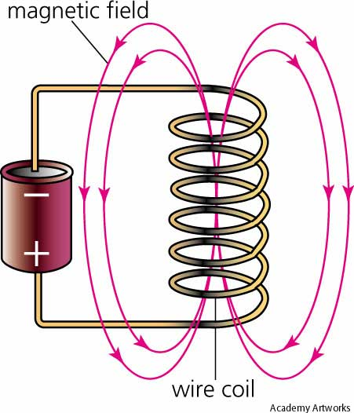**

**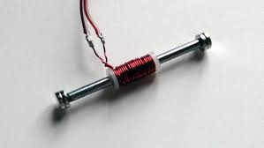**

**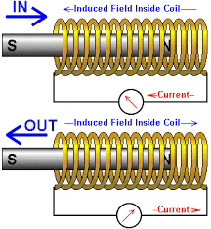**

**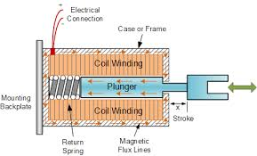**

**Relays**

**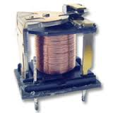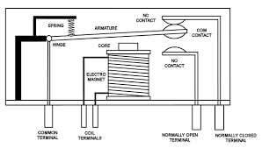**

**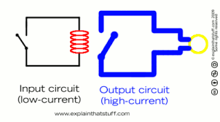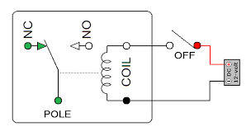**

**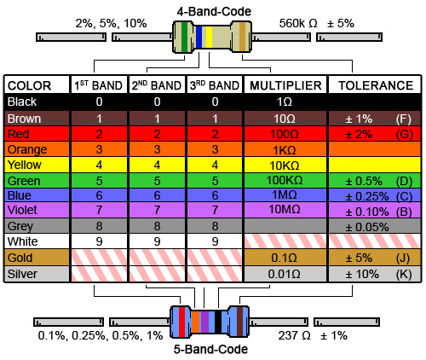Resistor Charts**

**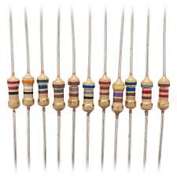**

**Transducers (INPUT DEVICES)**

**Thermistor - Reacts to temperature changes**

**When the temp goes up - its resistance goes down**

**Light Dependant Resistor (LDR)**

Reacts to changes in light levels

When the light level drops - itsresistance goes up.

**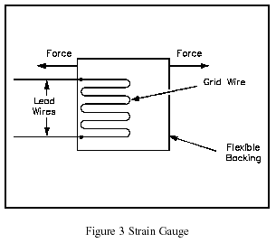Strain Gauge**

**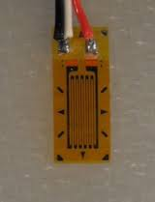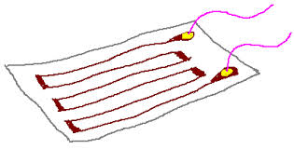**

They consist of a pattern of resistive foil which is mounted on a backing material. They operate on the principle that as the foil is subjected to stress, the resistance of the foil changes in a defined way.

**Capacitors**

**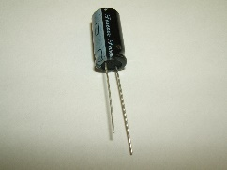**

1. The longer it takes the capacitor to charge up the longer the time delay.
2. The speed it takes the capacitor to charge up depends upon the speed of the electricity flowing into it.
3. **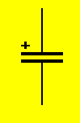**The speed of the electricity flowing into it is controlled by either a fixed resistor or a variable resistor.

If the symbol has a + sign then it is a polarised capacitor and must be connected in the correct polarity.

If the symbol does not have a + sign then it is a non-polarised capacitor and can be connected any war around.

**Printed Circuit Board (PCB)**

PCB’s are made using two common methods;

1. Etching
2. Milling

**At IST we make them using ETCHING**

**Astable & Monostable Circuits use a 555 timer chip (Integrated Circuit or IC)**

**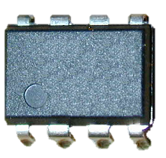**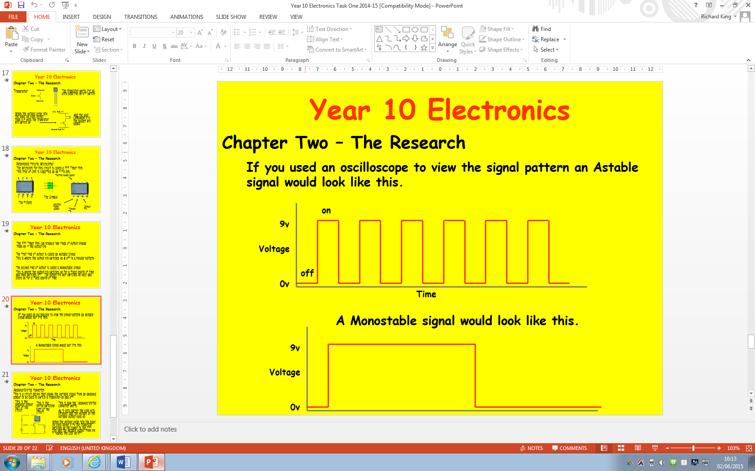

**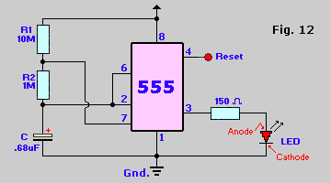An astable** circuit will continuously switch the output device on an off in a regular pattern.

The frequency of the pulses is determined by the strength of RI & R2 or by the capacity of the capacitor.

**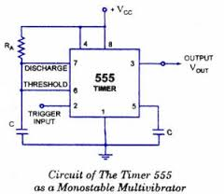When a monostable** circuit is triggered by activating a sensor attached to the trigger input connection. The circuit will switch on and stay on for a fixed period of time and then reset.

The duration of time that monostable stays on for is determined by the time that the capacitor takes to charge. The charge time is determined by the strength of R1 and/o the capacity of the capacitor.

**\*\*\***